Question 1: (4.0 Point)
At running the GUI looks like below:
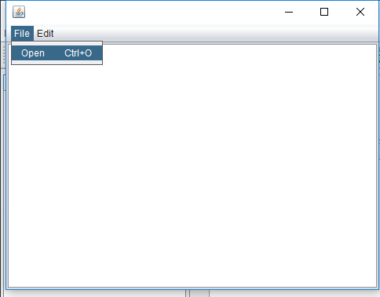
When you clock on “Open”, a dialog appears:
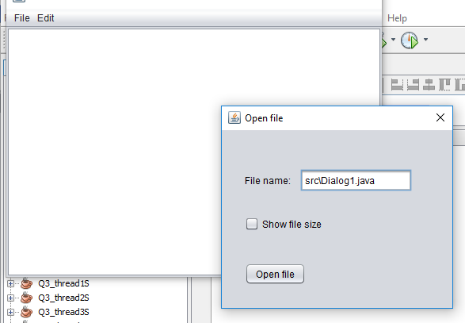

If you click “Open file”, the content of the file displayed inn the text area.
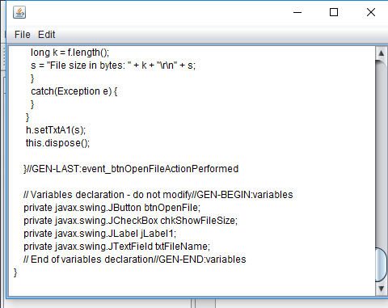
If the check box “Show file size” is checked, then the file size information appears in the first line:

